*Updated June 24, 2024*

**What’s new as of July 8, 2024?**

*When the cohort is at the “Ready” stage it will automatically be created as a class in Canvas, with the instructors and course coordinators you identify in the cohort tab added automatically to the class.*

See notes highlighted below with **“New!”**

# **Welcome to the Cohort Tab!**

Whether you are looking to manage your organization’s capacity or find actionable insights, the **‘Cohort’** tab in your **CO Portal** lets you see a list of all your cohorts and directly commit to a cohort and add instructors and course coordinators to classes in Canvas.

The **Cohort Tab User Guide** helps you learn to use the **‘Cohort’** tab better and faster. You will find details on features and other things that will help you use the **‘Cohort’** tab in the most efficient way possible.

***Please submit your support inquiries*** [***here***](https://support.aws.amazon.com/#/contacts/aws-restart) ***if you have any questions and or concerns.***

Contents

**Welcome to the Cohort Tab!** 1

**Instructions** 2

Finding the **‘Cohort’** Tab 2

Using the **‘Cohort’** Tab 2

Finding **‘Assigned’**, **‘Committed’**, **‘Ready‘**, **‘Cancelled’** Cohorts 2

Searching for a Cohort 3

Committing to an **‘Assigned’** Cohort (MPOC ONLY) 3

Frequently Asked Questions (FAQ) 5

What does it mean for a cohort to be ‘Ready’? 5

What do I do after my cohort is Ready? 5

How do I request a change to the **‘Classroom Start Date’** and/or **‘Clasrooom End Date’**? 5

How do I get a new instructor approved? 5

I have an instructor who has taught the re/Start curriculum for another CO. How do I get my instructor approved? 5

How do I update the instructor certification detail if it has already expired or will expire by the **‘Classroom End Date’**? 5

What do the different **‘Status’** mean and what is required to go from one status to the next? 6

How do I assign a new role in the CO Portal (MPOC ONLY)? 7

How can I request to add an approved instructor, course coordinator, and/or professional skills instructor to the course? 7

# **Instructions**

## Finding the **‘Cohort’** Tab

1. Log in to **CO Portal** using your username (email@xyz.abc.awsrestart) and password
2. Select the **‘Cohort’** tab

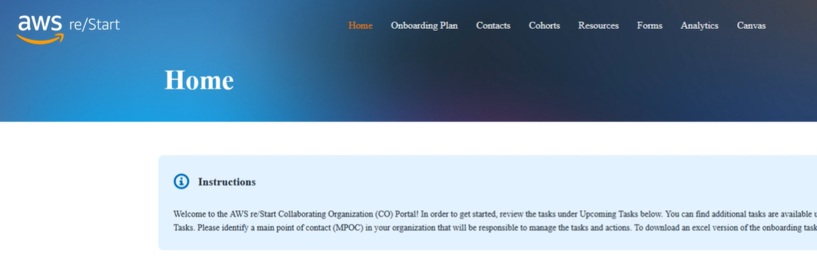

## Finding your Cohorts By Status

### Now that you are in the Cohort tab, you can find your **‘Assigned’**, **‘Committed’**, **‘Ready‘**, **‘Cancelled’** Cohorts

1. Select the picklist that has **‘All status’**
2. Select the **‘Status’** you want to view

NOTE: Multiple **‘Status’** can be selected

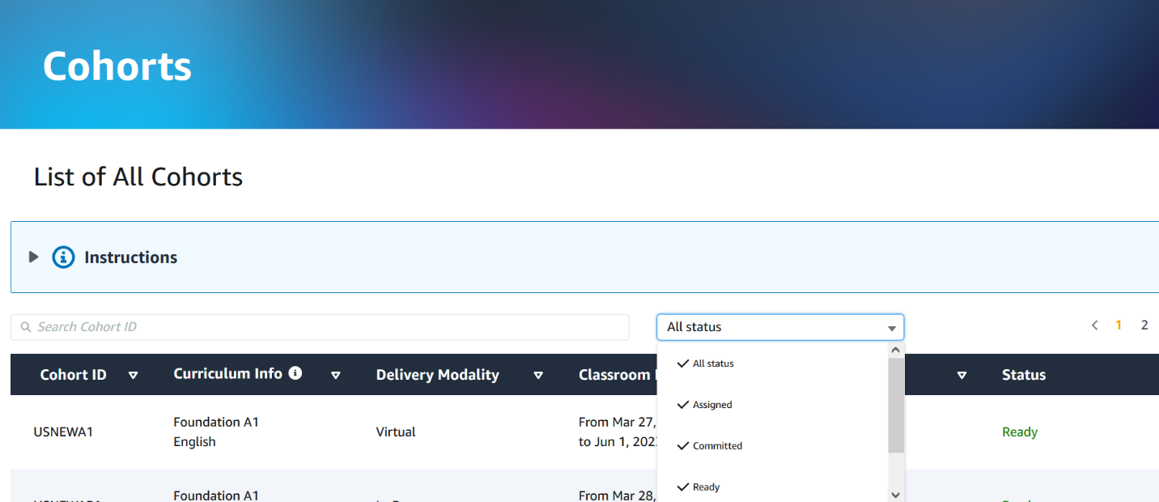

### Adding Instructors and Course Coordinators to the Cohort (MPOC ONLY)

1. Log in to **CO Portal** using your username (email@xyz.abc.awsrestart) and password
2. Select the **‘Cohort’** tab
3. Verify that the **'Classroom Start Date'** and **'Classroom End Date'** field are as expected (if not, please contact your AWS re/Start Regional Program Manager)
4. Select the three dots next to **‘Assigned’** Status
5. Select **'Edit'**

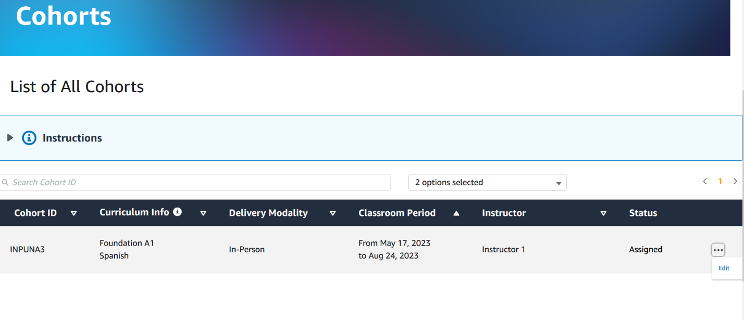

Confirm Classroom Period

1. Select Instructors from the **'Instructor'** picklist (**New!** These will be added automatically to Canvas once you select ‘Committed’).
2. **New!** Select a ‘Course Coordinator’ from the picklist (These will be added automatically to Canvas once you select “Commit”).

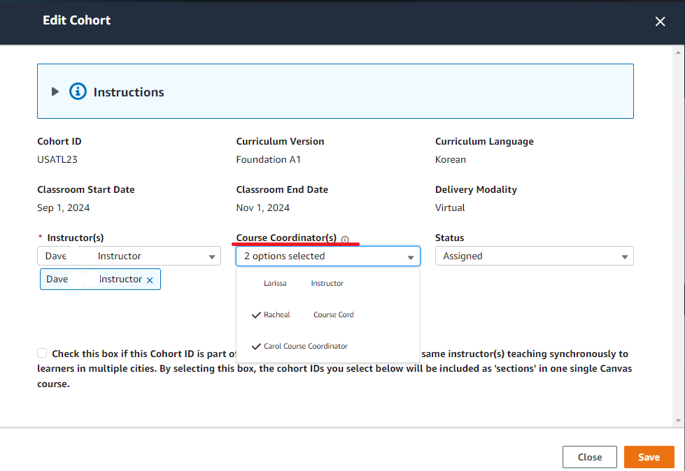

Approved instructors with and valid certification until the classroom end date

### Creating a multi-cohort classroom (MPOC ONLY)

1. **New!** If this is part of a multi-cohort Canvas classroom, associate the multi-cohorts at this stage. In the ‘Edit Cohort’ pop up, you can now associate multi-cohorts with one another. Once users associate the cohorts, they will automatically go under the same Canvas course as multiple sections in the course.

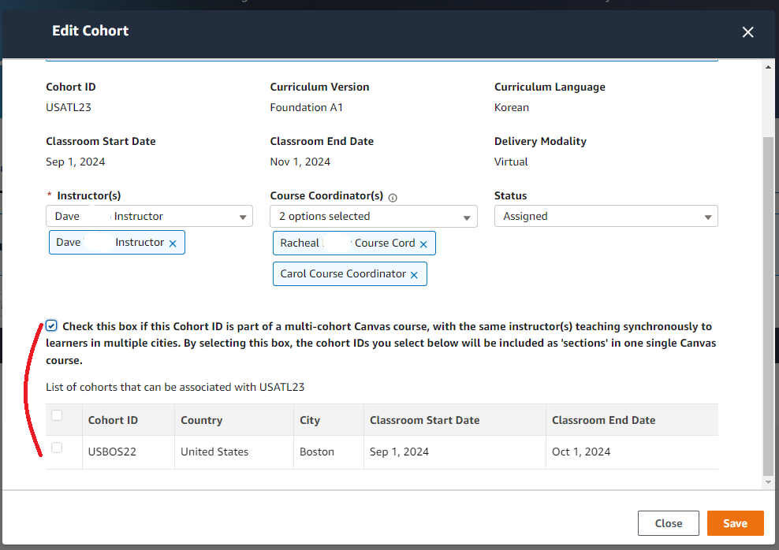

### Committing to a cohort automatically creates a class in Canvas (MPOC ONLY)

1. Change **'Status'** field to **'Committed'**

**New!** NOTE: Once you select “Commit,” if the Instructor is qualified, has taken the Instructor Preparedness Course, and it is at least 14 days from the start date, then the class will be created automatically in Canvas. Therefore, do not select “Commit” until you have selected all of the Instructor/s and Course Coordinator/s you wish to assign to this cohort.

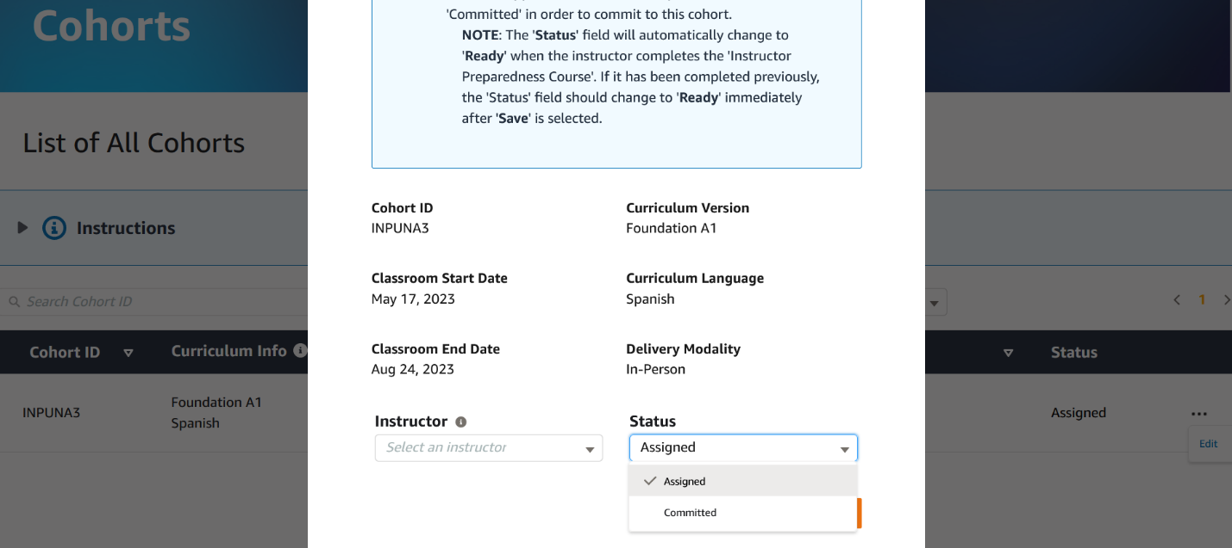

1. Select **'Save'**

**New!** The system will automatically change the status to **‘Ready’** and create the class in Canvas with the selected Instructors and Course Coordinators added automatically (pending that the following conditions are met)*:*

* *Instructor has taken the most recent Instructor Preparedness Course*
* *Instructor’s certification does not expire before classroom end date*
* *Cohort start date is at least 14 days in the future*

If the above conditions are not met, the class will not be created and will remain in **‘Commited’** state.

1. The Instructors and Course Coordinators will receive an email notification once the class has been created. This may take up to 2 hours.

## Frequently Asked Questions (FAQ)

### What does it mean for a cohort to be ‘Ready’?

* The cohort is ‘Ready’ once the instructor has finished the ‘Instructor Preparedness Course’ in Canvas, and once the MPOC changes the stage to “Committed.” **New!** At this point, the class will be created in Canvas. The instructor and course coordinator will receive a notification letting them know once the class has been created.

What if I want to add more Course Coordinators or Instructors, after the cohort has been ‘Committed’, moved to ‘Ready’ by the system, and created in Canvas?

* To add more Course Coordinators or Instructors after the class has been created in Canvas, ***submit your request to AWS re/Start Support*** [***here***](https://support.aws.amazon.com/#/contacts/aws-restart)
  + Provide the following information:
    - Name of instructor or course coordinator
    - CO Name
    - Email of person to be added to the cohort
    - Cohort ID

### How do I get a new instructor approved?

* ***Please submit the '***[***Instructor Proposal Form***](https://awsacademy--devfull.sandbox.my.site.com/restart/s/form-submission/instructor-proposal-form)***'***
* The instructor must take the most recent Instructor Preparedness Course in Canvas in order to be eligible to teach.

### I have an instructor who has taught the re/Start curriculum for another CO. How do I get my instructor approved?

* If this is the first time this instructor has taught with your CO, the process is the same as with a new instructor.
* ***Please submit the '***[***Instructor Proposal Form***](https://awsacademy--devfull.sandbox.my.site.com/restart/s/form-submission/instructor-proposal-form)***'***

### How do I update the instructor certification detail if it has already expired or will expire by the **‘Classroom End Date’**?

* ***Please submit your support inquiries*** [***here***](https://support.aws.amazon.com/#/contacts/aws-restart)
* Provide the following information:
  + Name of instructor
  + CO Name
  + Email instructor
  + Cohort ID
  + Updated certification Credly link

### What do the different **‘Status’** mean and what is required to go from one status to the next?

|  |  |  |
| --- | --- | --- |
| Status | Owner | Action Taken to Move to Status |
| 1. Assigned | Regional Program Manager (RPM) | * RPM assigns a **‘Cohort’** to your CO in your **‘Cohort’** tab |
| 1. Committed | CO MPOC | * CO MPOC verifies **‘Classroom Start Date’** and **‘Classroom End Date’** field in CO Portal (contact your AWS re/Start RPM if the dates needs updating) * CO MPOC selects an instructor and, optionally, course coordinator from the picklists * [Optional] if this is a multi-city cohort, select the checkbox to idenfity the cohort as such, then select the corresponding cohorts * CO MPOC changes **'Status'**field to **'Committed'** |
| 1. Ready | System | * System verifies the following:   + Instructor is approved,   + **‘Instructor Preparedness Course’** is completed, and   + Instructor has valid certification until the **‘Classroom End Date’**   + Course start date is at least 14 days in the future * If the above conditions are met, the system automatically changes **‘Status’** field to **‘Ready’,** otherwise an error message will be displayed |
| New!   1. Class Created | CO MPOC | * System automatically creates the class in Canvas * Instructors and Course Coordinators identified in the Cohort tab at ‘Assigned’ stage are automatically added to the class in Canvas * Instructors and Course Coordinators will receive an email notifying them that the class has been created in Canvas. * This class will now appear in the “Courses Created in Canvas” tab |
| 1. Cancelled | RPM | * RPM changes **‘Status’** field to **‘Cancelled’** |

### How do I assign a new role in the CO Portal (MPOC ONLY)

1. Log in to **CO Portal** using your username (email@xyz.abc.awsrestart) if they do not teach with other COs – if they teach with other COs they will have a unique username for each CO) and password
2. Select the **‘Contacts’** tab
3. Select the three dots next to **‘Role’** column for the individual for whom you want to change the role
4. Select **'Edit'**
5. Select new **‘Role’**
6. Select the right arrow
7. Select **‘Save’**

### How can I request to add a Professional Skills Instructor to the course?

* ***Please submit your support inquiries*** [***here***](https://support.aws.amazon.com/#/contacts/aws-restart)
* Provide the following information:
  + Name
  + Collaborating Organization
  + Cohort ID of existing class in Canvas
  + Role of user being added to the existing class in Canvas (TYPE PROFESSIONAL SKILLS INSTRUCTOR)
  + Reason as to why they need to be added in the existing class in Canvas